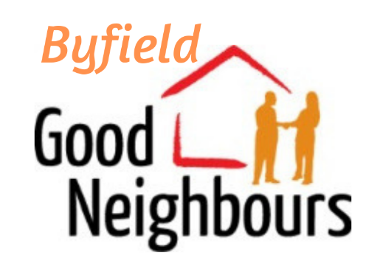
Frequently
Asked
Questions

Who are we?
The Byfield Good Neighbour Scheme uses voluntary effort from local people to provide help for anyone in the village who needs assistance with transport, household tasks, companionship, practical support following illness, letter writing, form filling, and more...

How does it work?
Call 01327 227000 between 8am and 2pm daily. A co-ordinator will arrange for one of our registered volunteers to help. Be prepared to leave a message, the co-ordinator may be busy.

How much does it cost?
Nothing. Funding for our running costs comes from donations from organisations, such as Daventry District Council, local charities and from individual supporters.

Is it safe?
All our volunteers have Safeguarding certification, are fully insured and carry photographic identity cards at all times.

Who has my information?

All data is held securely, and we are under strict obligations to not discuss you or your needs with anyone you have not explicitly said you want us to talk to on your behalf.

Can I help?
If you'd like to volunteer we'd love to hear from you.
Either ring our phone number above or email ByfieldGNS@gmail.com

I can only do certain things, can I still help?
Everyone can do something for someone else, so we’d still love to have you on our books and we will match someone’s need with your skill-set. You can also be a volunteer and a user, so what might we help you with?

I only have a certain amount of time, can I still help?
Absolutely! Tasks will vary, from a regular hour a week, to 30mins once a month. Let us know what you can offer, time and skills, and we will find someone for you to help.

I know someone who needs help, what should I do ?
Check that they know we exist, and encourage them to get in touch. If you don’t feel comfortable doing that, we are more than happy to reach out to people.

I already help people, why do we need a Good Neighbour Scheme ?
Great! We’re not trying to step on anyone’s toes, but if you’d like us to cover for you whilst you’re on holiday, for example, then do get in touch – we’ll be happy to support you in your support for your neighbour, however temporarily.

Will you take business from me, a local tradesperson?
We do not offer specialist care or play any role that should be left to professional, qualified services. Nor do we provide volunteers to carry out skilled tasks that are appropriate for qualified tradespeople. We are very happy to recommend local tradespeople / services if asked, so make sure we know about you, and you can claim to be ‘Recommended by our local Good Neighbour Scheme’!!

What’s the catch?
There is none!! See our “Who benefits” on our page on the Parish Council site for more on how this is good for the whole community.

Do you have any more questions?
Call our number and ask! We want to provide what our neighbours need, so you will be helping us do better by asking.

When does it start?
Now! We recruited volunteers during September and, in this edition of The Byword, you should have a fridge magnet & a small card to pass to friends or family so they can contact us on your behalf if necessary. Extra cards are available from the Scheme or the GP Surgery as needed.

Byfield
Good Neighbour Scheme
Tel: 01327 227000
Email: ByfieldGNS@gmail.com

