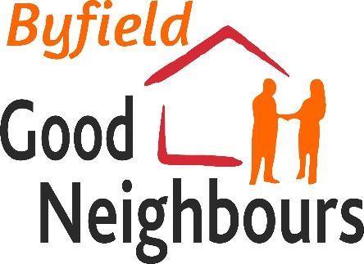
Who
Benefits?
(We all do!!)

Who are we?
The Byfield Good Neighbour Scheme uses voluntary effort from local people to provide help for anyone in the village who needs assistance with household tasks, companionship, transport, practical support following illness, letter writing, form filling, and more...

How does it work?
See our FAQs for more on how the scheme will work.

Why are we setting this up in Byfield?
Byfield is already a great place to live and Good Neighbours schemes are a wonderful way of bringing a community together to help everyone - both the local volunteers as well as the people they are helping.

For volunteers, the scheme is a chance to :
- Get involved with your community and do as much or as little as you want. There’s no need to feel awkward if you can’t always help
- Meet new people who you might not have met otherwise, including those from different generations
- Make good use of whatever time you have to spare as well as particular skills you may have, such as IT or even just your height !!
The benefits for our users include:

- A chance to access support to complete jobs that may normally be difficult to do alone
- An opportunity to meet new people and make friends
- People no longer need to feel they are ‘bothering' neighbours if they need to ask for help frequently
- Help people to stay in their own home for longer as they get older

You can, of course, be both a volunteer and a recipient!

